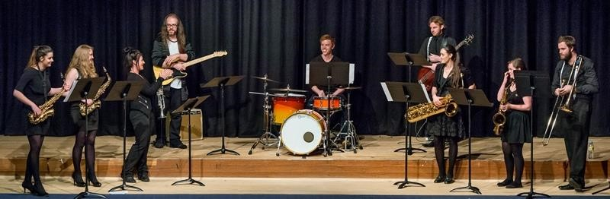
AN INVITATION TO JOIN THE UNE COLLEGES’ CHAMBER ENSEMBLE PROGRAMME in 2019
Rehearse and perform weekly, with professional tutors – at no cost!
This programme is offered to all UNE College students and is administered from Austin College and include:

String Ensemble Wind Ensemble Vocal Ensemble Jazz Ensemble Guitar Ensemble Solo Musicians

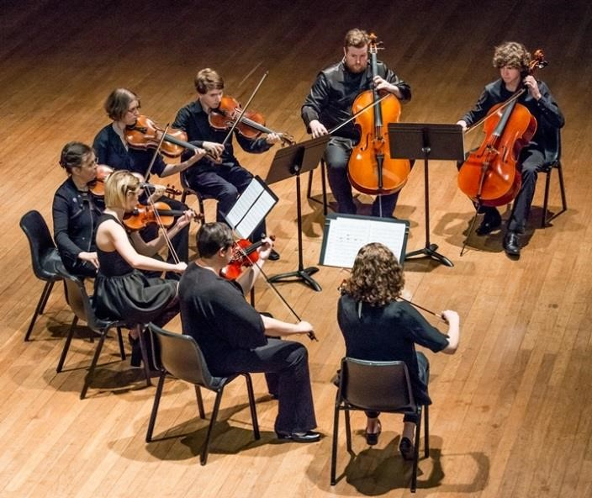

The ensembles are formed from the huge talent which emerges from the student body from all Colleges in UNE each year. We rehearse once each week at a regular time with highly skilled tutors and present two public concerts annually. Some of the groups have also performed at prestigious UNE and Armidale events and successfully participated in local eisteddfods.

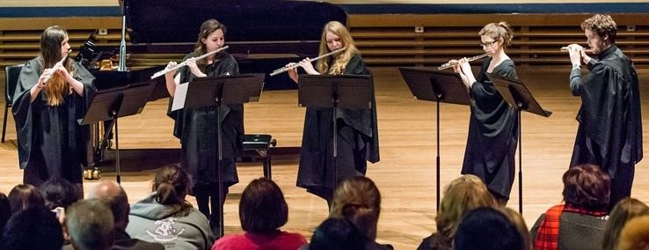

Expression of Interest Form
UNE Colleges’ Chamber Ensembles, 2019

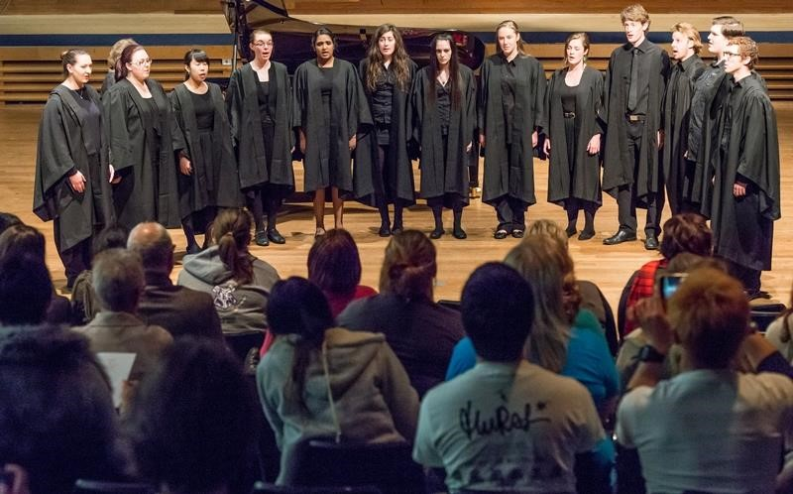

Please provide the following information and email to Andrea Gledhill, Head of Austin College, University of New England agledhi2@une.edu.au by March 12, 2019.
Enquiries: 0429 362 874

NAME: UNE STUDENT NUMBER:
PHONE:
INSTRUMENT: …………………………………………………………………………………………………………
AMEB EXAMS PASSED: ………………………………………………………………………………………………………………….
TRINITY COLLEGE EXAMS PASSED: ………………………………………………………………………………………………..
CHAMBER CHOIR - VOICE TYPE: (Soprano, Alto, Tenor or Bass)
CHORAL EXPERIENCE:

Interested but not sure?

Come along to an introductory meeting with our tutors and fellow students at 5pm on Tuesday March 12 in the Austin College Large Common Room – all will be revealed then!

